
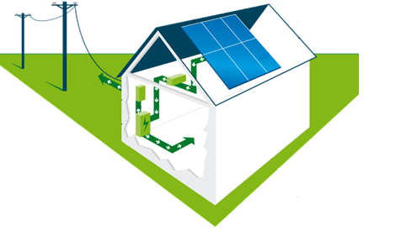

Clear
Energy

nergy


Solar PV Proposal

Unique Proposal Reference No: 20-09-002
(When signing sales order please ensure this quote reference is correct)
On behalf of:
Village Hall
High Street
Hawksbury Upton
South Gloucestershire
GL9 1AU

Village Hall

Prepared by:
EGS Solutions
Manderlay,
53 Horsepool
Wiltshire SN15 2HD

EGS Solutions Ltd are at the forefront of Photovoltaic (PV) technology within the UK.
Our sole purpose is to deliver cost effective, efficient Solar PV solutions which will maximise the return on our clients’ investment, reduce the need for electricity from the National grid using a sustainable source and at the same time reducing UK Carbon emissions.

Whether you are a householder wishing to install a 2KWp system to your home, a large premises owner requiring a commercial rooftop system to one property or a portfolio, or even an investor or investment group looking to develop a solar farm, EGS Solutions Ltd will provide highest quality advice on which you can base your decisions.

The performance of Solar PV systems is impossible to predict with certainty due to the variability in the amount of solar radiation (sunlight) from location to location and from year to year. This estimate is based upon the Government’s standard assessment procedure for energy rating of buildings (SAP) and is given as guidance only. It should not be considered as a guarantee of performance.
The estimate of performance takes into account the size of the installation and how much sunlight it will receive. The amount of sunlight the system will receive is dependent on the angle of the panel and the direction it faces. Other factors, such as shadings, need also to be taken into consideration.
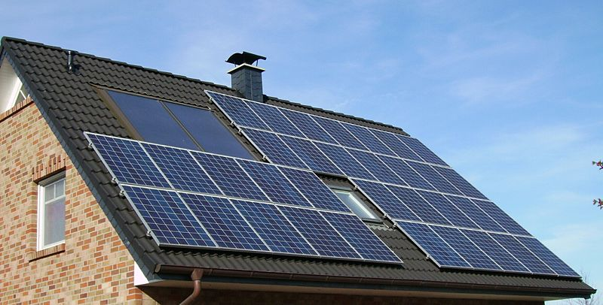

EGS Solutions Ltd provide the following services:

- Initial feasibility advice and outline cost estimates

- System design and optimisation

- Engineering and project management
- Installation

- DNO and planning consultancy

- Maintenance and system monitoring.

All of our systems are designed using highest quality components from our manufacturer partners who include:











Solar PV Explained
Solar electricity systems capture the sun's energy using photovoltaic (PV) cells. The cells convert the sunlight into electricity, which can be used to run household appliances and lighting. PV cells don't need direct sunlight to work - you can still generate electricity on a cloudy day. PV cells are panels you can attach to your roof or walls. Each cell is made from one or two layers of semi-conducting material, usually silicon.
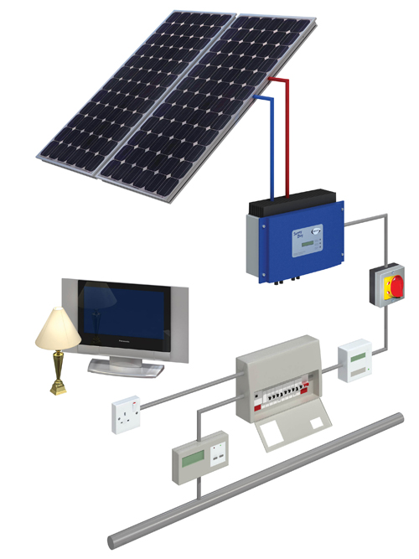
When light shines on the cell it creates an electric field across the layers. The stronger the sunshine, the more electricity is produced. PV cells come in a variety of shapes and colours, from grey "solar tiles" that look like roof tiles to panels and transparent cells that you can use on conservatories and glass. The strength of a PV cell is measured in kilowatt peak (kWp). That's the amount of energy the cell generates in full sunlight.

Clean Energy Cash Back Scheme
Feed-in Tariffs (FITs) became available in Great Britain from 1st April 2010. Under this scheme, energy suppliers make regular payments to householders and communities who generate their own electricity from renewable or low carbon sources such as solar electricity (PV) panels or wind turbines.

The scheme guarantees a minimum payment for all electricity generated by the system, as well as a separate payment for the electricity exported to grid. These payments are in addition to the fuel bill savings made by using the electricity generated on-site.
The tariffs available and the process for receiving them vary, depending on when the technology was installed, and whether the system and the installer were certificated under the Microgeneration Certification Scheme (MCS).
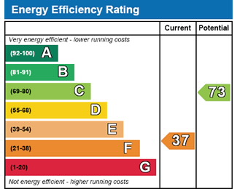
To get FITs at the standard rate for solar PV, your property needs to have an Energy Performance Certificate (EPC) of band D or
higher.

What is an EPC?

EPCs tell you how energy efficient a building is and give it a rating from A (very efficient) to G (inefficient). They let the person using the Building know how costly it is likely to be to heat and power, and what carbon dioxide emissions there will be. Once produced EPC’s are valid for ten years. The EPC will also state what the energy efficiency rating could be if improvements are made, and highlights cost-effective ways to achieve a better rating.
If you have an EPC which shows that your property is a band E, F or G you will need to carry out energy efficiency improvements before you apply for the FITs or receive the FIT at the lower rate of 9p/kWh for the lifetime of the tariff, currently 20 years. If you’re solar PV system is going to be on an outer building with a different meter that supplies your house to the e.g barn your property will require an exempt certificate, excluding you from needing an EPC grade D or above.
New rules on the payment of the Feed-in Tariff (FITs) for solar PV installations are coming into force on 1st April 2012. From that date you are required to send to your FITs supplier an Energy Performance Certificate (EPC) showing that your property has an EPC band D or

better at the time of your application to receive the standard rate of FITs of 14.9p/kWh (for a system under 4kWp) rather than the lower rate of 9p/kWh.
If your property is a band E or less when you first apply for FITs then you will receive the FIT at the lower rate. Note that even if you improve your property’s EPC band to a D or higher at a later date you will still get the lower rate.
This new requirement has been introduced by the UK Government because they want to ensure that homes meet minimum standards of energy efficiency before they encourage the installation of solar PV. The UK Government states that this is because reducing demand for energy is one of the most cost-effective ways of reducing carbon emissions and therefore a process that should be prioritised before installing microgeneration technologies such as solar PV.

If you are eligible to receive the FIT then you will benefit in 3 ways:

- Generation Tariff – a set rate paid by the energy supplier for each unit (or kWh) of electricity you generate. This rate will change each year for new entrants to the scheme (except for the first 2 years), but once you join you will continue on the same tariff for 20 years.
- Export Tariff - you will receive a further 4.5p/kWh from your energy supplier for each unit you export back to the electricity grid, i.e. when it is not used on site. The export rate is the same for all technologies.
- Energy Bill Savings – tenants/residents will be making savings on their electricity bills because generating electricity to power their appliances means they don’t have to buy as much electricity from their energy supplier. The amount saved will vary depending how much of the electricity is used on-site.

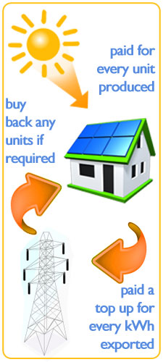

Planning Considerations
Planning permission may be needed if the property where the installation is to take place is within a Conservation Area, National Park or an Area of Outstanding Beauty. If the property is a listed building you should assume that planning consent would be required. In any of these circumstances we would strongly suggest you contact your local planning authority.
Whilst we will assist you in gaining any particular permission, it will be your responsibility to ensure these permissions are in place. We cannot be held responsible for any installations carried out where planning permission was required but not obtained and no refunds will be offered.
Structural Issues
The Microgeneration Certification Scheme states that if we are in any doubt as to the structural suitability of the building then a structural engineer should be consulted. From our part, we will access the suitability and will only install if we feel the structure is suitable. If we are in any doubt we will liaise with you with a view to consulting a suitably qualified person. Dependent on the circumstances, this will either be at our or your expense. We will make it clear, in writing, on this matter if it should arise.
Your Quotation
The quotation is only valid for 30 days before another one will need to be issued.
If the system performs in line with our predictions the following would apply:

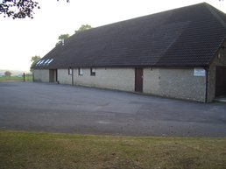

Installation | Retrofit
Orientation | East South East
Area Coverage | 73m2
Property Type | Detached
Degree of Shading | 0%

Your System
Size of System | 11kWp
Annual Generated Power | 10120kWh
Income From Clean Energy Cash-back | £1,272
Estimated Income From Export

Estimated Fuel Bill Savings | £1,417
Total Income and Savings | £2,689

Quotation
Total Cost for a 11kWp System | £14,850
Total Expected Annual Income from your System | £2,689
Total Income Estimated over 20 Years | £105,393
Return of Capital Investment Expected (a/b) | 4 Years
Deposit Required with Order (30%) | £4,455
Further Deposit after 8 Days (30%) | £4,455
Balance on Completion after Commissioning (40%) | £5,940
44 250w Solar PV Panels are to be used

payback period | 4 Years

None of us can predict accurately what will happen in the future when it comes to inflation and electricity prices or for the payback time we have assumed. Although if maintenance’s cost occur and extra charge may apply.
To calculate how long the system will take to pay for itself, you can divide the total cost you have paid for the system and divide it by the benefit you will receive each year.
Commissioning the system
The solar PV system will be commissioned according to the MCS installation standard to ensure that the system is safe, has been installed according with the documented procedures and manufacturer’s requirements and is operating correctly in according with the design system.
Following the testing and commissioning of the system, a detailed operation manual will be provided to you within 7 days.

Registering for FITS
We will register your installation on the MCS database and send you the MCS. You must send your MCS to your chosen licensed electricity supplier along with your energy application form and also a proof of ownership of the system, in order to receive your FIT payment.

Cancellation Rights
Following the signing of the contract you have a cooling off period of seven working days, during which you may cancel the contract without penalty. If you cancel within this time, we will return any deposit you may have paid in full. If you cancel after this time, we may have to make reasonable charges based on any costs we have incurred.
Should you wish to cancel, we have provided you with a cancellation form. You must complete this form, or state in writing to us that you wish to cancel the contract. You should post to the address on the quotation or send us an email to enquiries@egs-biomass.co.uk. We would suggest that if posting to send recorded delivery in ensuring it arrives.
Any deposit or advance payment you will make to use according to the timescale set out in the proposal will be placed into a ‘Client Bank Account’. These deposits and advance payments can only be used to carry work out under this contract.
Should we cease trading because of receivership, administration or bankruptcy the monies in that back account will be returned to you or will be given to another MCS Approved Contractor to complete the work.



