www.hawkesburyshow.org
126th HAWKESBURY HORTICULTURAL SHOW & FAIR

Saturday 27th August 2011

At the Village Hall and Recreation Field, High Street, Hawkesbury Upton

Horticultural Produce and Crafts Marquee

Archery ⇨ Beer Tent ⇨ Craft Stalls ⇨ Pimms Tent ⇨ Refreshments

Hog and Deer roast ⇨ Fairground rides ⇨ Hawks and Owls

● John Caudrey – juggling, stilt walking, unicycle riding
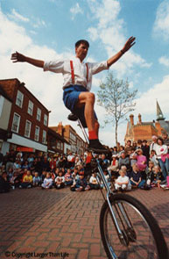
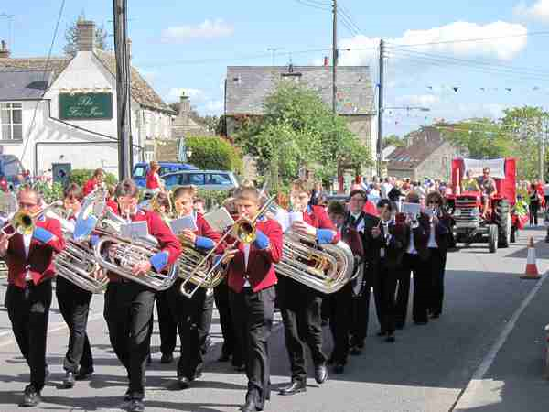
●“Ragged and Old” Morris dancers
● Nailsworth Silver band
● Fast draw
Wild West handgun challenge

Carnival Parade through the village starting with crowning The Carnival Queen at The Plain at 2.00pm (High Street closed to vehicles 1.30pm – 3.00pm)

Gates Open at 12.30pm

Entry (Pay at the gate) - Adults £4, Senior Citizens £3, Children £2, Family ticket £10

Prepaid tickets available at The Village Shop & The Post Office, Hawkesbury Upton

Free Car Park off High Street

Dogs welcome on a lead : Disabled parking in the Village Hall car park : Wheelchair accessible

For further information or to book a stall phone 01454 232910 or email: Vicky@the-hollies.co.uk

